**BRAINSTORM & PRIORITIZE IDEAS**

**--------------------------------------------------------------------------------------------**

|  |  |
| --- | --- |
| NAME | T.SURESH KUMAR |
| NM ID | EA32343CFBC1AD09D4E465F983490A2F |
| PROJECT | HOW TO CREATE A GOOGLE ADS COMPAIGN FOR YOUR BRAND |

**BRAINSTORMING AND IDEA PRIORIZATION :**

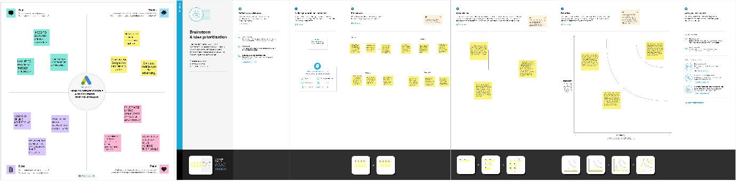

**BRAINSTORMING AND IDEA PRIORIZATION LINK :**

<https://app.mural.co/t/suresh8378/m/suresh8378/1698856033880/24cfa6386b8102a747ea231f7f6b0db4e9520d98?sender=u30a67f9b441b4e205e280708>

**EMPATHY MAP**

**--------------------------------------------------------------------------------------------**

|  |  |
| --- | --- |
| NAME | T.SURESH KUMAR |
| NM ID | EA32343CFBC1AD09D4E465F983490A2F |
| PROJECT | HOW TO CREATE A GOOGLE ADS COMPAIGN FOR YOUR BRAND |

**EMPATHY MAP:**

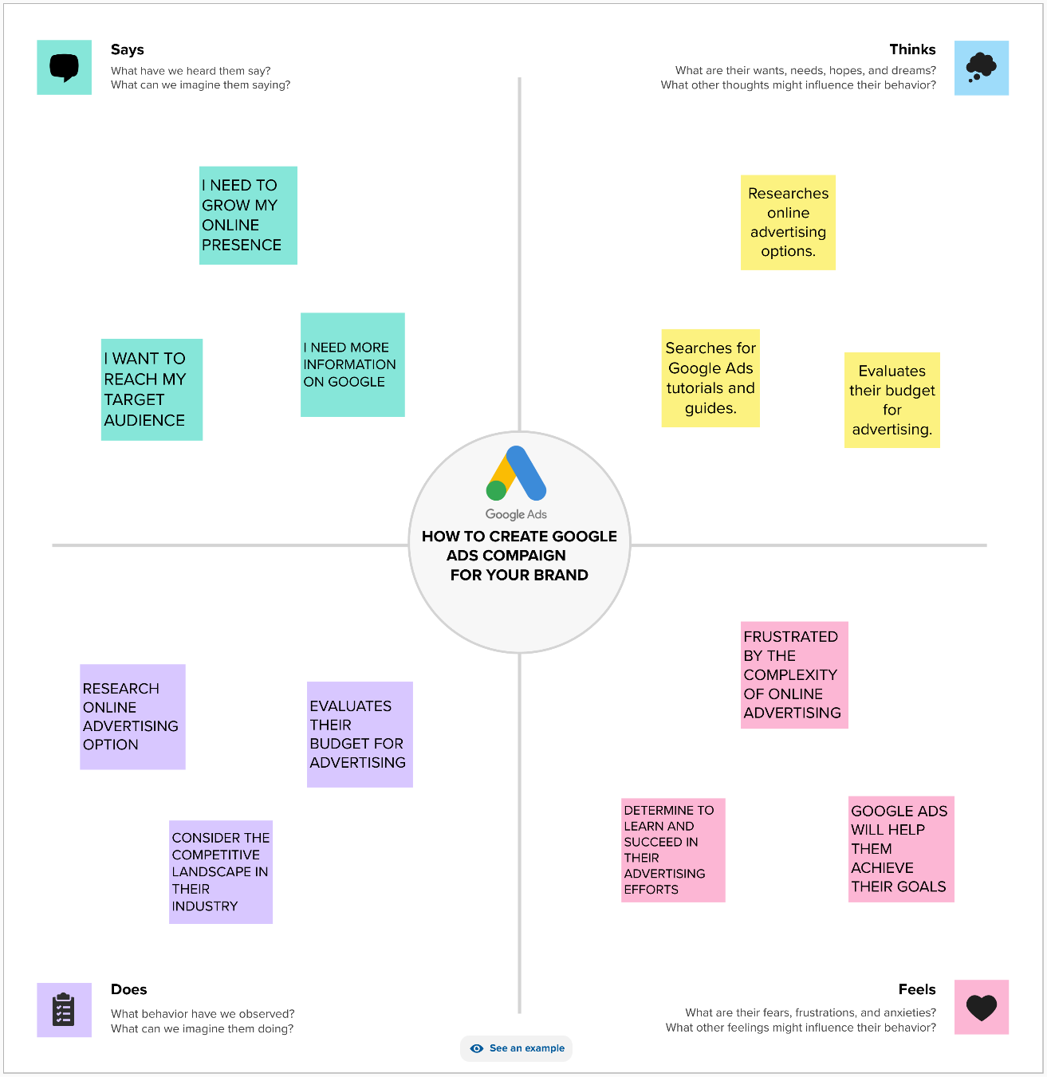

**EMPATHY MAP LINK:** <https://app.mural.co/t/suresh8378/m/suresh8378/1698852627354/fa012415751f9725e867fe96537cabefcf0b6479?sender=u30a67f9b441b4e205e280708>

**IDEATIONPHASE & PROBLEM STATEMENT**

**--------------------------------------------------------------------------------------------**

|  |  |
| --- | --- |
| NAME | T.SURESH KUMAR |
| NM ID | EA32343CFBC1AD09D4E465F983490A2F |
| PROJECT | HOW TO CREATE A GOOGLE ADS COMPAIGN FOR YOUR BRAND |

**CUSTOMER PROBLEM STATEMENT TEMPLATE:**

Create a problem statement to understand your customer's point of view. The Customer Problem Statement template helps you focus on what matters to create experiences people will love.

A well-articulated customer problem statement allows you and your team to find the ideal solution for the challenges your customers face. Throughout the process, you’ll also be able to empathize with your customers, which helps you better understand how they perceive your product or service.

**THE PROBLEM STATEMENT :**

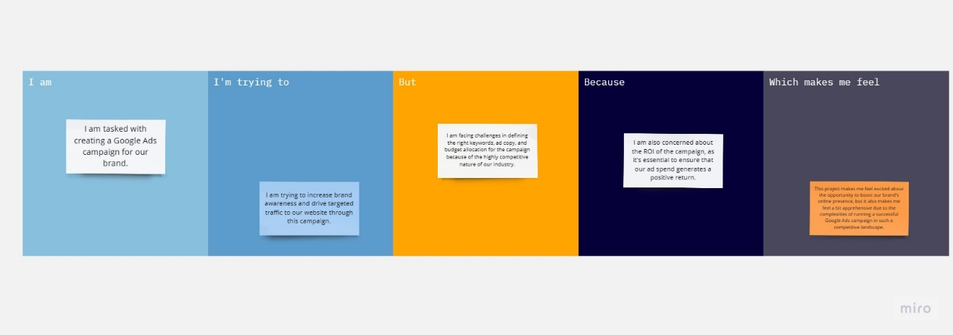

**REFERENCE LINK:**

<https://miro.com/app/board/uXjVNTfdNPA=/>

Project Design Phase-**|**

**Proposed Solution Template**

**--------------------------------------------------------------------------------------------**

|  |  |
| --- | --- |
| NAME | T.SURESH KUMAR |
| NM ID | EA32343CFBC1AD09D4E465F983490A2F |
| PROJECT | HOW TO CREATE A GOOGLE ADS COMPAIGN FOR YOUR BRAND |

**Proposed Solution for Creating a Google Ads Campaign for Kawasaki:**

This project aims to establish an effective online advertising campaign through Google Ads to promote the products and services of [Your Brand]. Commencing on [Start Date] and concluding on [End Date], our primary objectives include driving targeted traffic to the brand's website, increasing conversions, and achieving a positive return on ad spend (ROAS) within a defined timeframe. To facilitate this, we propose a multifaceted solution encompassing a user-friendly web application for campaign management and monitoring. Backed by a suite of backend services, such as User Management, Campaign Configuration, Google Ads API Integration, Data Storage, Notification, and Reporting services, the system will facilitate seamless campaign creation and optimization. The solution integrates with the Google Ads API for real-time campaign management, while ensuring data integrity and security through robust data encryption and access controls. Regular compliance checks and updates will be conducted to align with Google Ads policies. The solution encompasses comprehensive testing, monitoring, and disaster recovery strategies, and detailed documentation to ensure its effectiveness and long-term success. By continuously optimizing campaigns and adhering to best practices, we aim to achieve the project's objectives and drive success for kawasaki.

Project Design Phase-**|**

**Solution Architecture**

**--------------------------------------------------------------------------------------------**

|  |  |
| --- | --- |
| NAME | T.SURESH KUMAR |
| NM ID | EA32343CFBC1AD09D4E465F983490A2F |
| PROJECT | HOW TO CREATE A GOOGLE ADS COMPAIGN FOR YOUR BRAND |

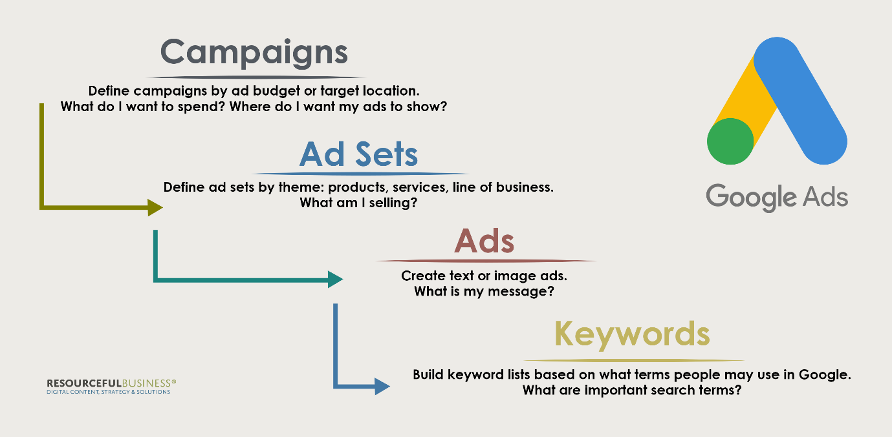

**1. User Interface:**

**- The solution should have a user interface that allows marketers and advertisers to input campaign details, including ad copy, targeting options, and budget settings. This interface can be a web application or a standalone software.**

**2. Authentication and Authorization:**

**- Users should be authenticated to access the system. OAuth or other authentication mechanisms can be used for secure access.**

**3. Frontend Application:**

**- This component handles user interactions and communicates with the backend services. It should provide a user-friendly interface for campaign management.**

**4. Backend Services:**

**- The backend consists of several services that handle different aspects of campaign creation and management:**

**- User Management Service: Manages user accounts, permissions, and access control.**

**- Campaign Configuration Service: Allows users to define campaign settings, such as budget, targeting, and ad creative.**

**- Google Ads API Integration: This service interacts with the Google Ads API to create, manage, and optimize campaigns.**

**- Data Storage: Stores campaign data, user profiles, and historical performance data.**

**- **Notification Service: Sends alerts and notifications to users about campaign updates or issues.**

**- **Reporting Service: Gathers and processes campaign performance data for reporting and analytics.**

**5. Google Ads API Integration:**

**- This component communicates with the Google Ads API to create and manage campaigns, ad groups, ads, and keywords. It should handle authentication, making API requests, and receiving responses.**

**6. Data Storage:**

**- Campaign data, user profiles, and historical performance data should be stored securely. You can use databases (e.g., SQL or NoSQL databases) for this purpose.**

**7. Reporting and Analytics:**

**- Collects campaign performance data and generates reports. Data visualization tools or dashboards can be used to present insights to users.**

**8. Notifications:**

**- The notification service sends alerts to users for various events, such as campaign approvals, policy violations, or budget overspending.**

**9. Monitoring and Logging:**

**- Implement monitoring and logging to track system health, performance, and errors. Tools like Prometheus and Grafana can be used for monitoring.**

**10. Security Measures:**

**- Implement security measures at every layer, including encryption of sensitive data, API authentication, and access control to prevent unauthorized access.**

**11. Compliance:**

**- Ensure compliance with Google Ads policies and regulations to avoid any policy violations during campaign creation and management.**

**12. Testing and Quality Assurance:**

**- Develop a testing strategy to ensure that the system works as expected and does not have any critical issues. Automated testing can help in this regard.**

**13. Deployment and Scalability:**

**- Deploy the solution in a scalable and reliable environment. Use containerization (e.g., Docker) and orchestration (e.g., Kubernetes) for managing services.**

**14. Disaster Recovery and Backup:**

**- Implement a disaster recovery plan to ensure data integrity and availability in case of system failures.**

**15. Documentation:**

**- Document the solution architecture, APIs, and user guides for the marketing team and developers.**

**16. Continuous Optimization:**

**- Continuously monitor campaign performance and optimize based on data insights. This may involve adjusting bidding strategies, ad creatives, and targeting options.**

Project Design Phase-**||**

**CLOUD DEPLOYMENT**

|  |  |
| --- | --- |
| NAME | T.SURESH KUMAR |
| NM ID | EA32343CFBC1AD09D4E465F983490A2F |
| PROJECT | HOW TO CREATE A GOOGLE ADS COMPAIGN FOR YOUR BRAND |

1. Select a Cloud Service Provider:

- Choose a cloud service provider, such as Amazon Web Services (AWS), Google Cloud Platform (GCP), or Microsoft Azure, based on your preferences, familiarity, and specific requirements.

2. Infrastructure Planning:

- Determine the type of infrastructure you need, including virtual machines, databases, and storage solutions.

- Set up virtual servers to host your web application, database, and other components.

3. Containerization and Orchestration:

- Consider using containerization technologies like Docker to package your application and its dependencies.

- Utilize container orchestration platforms such as Kubernetes to manage and scale containers efficiently.

4. Database Setup:

- Choose a database service provided by the cloud platform (e.g., Amazon RDS, Azure SQL Database, Google Cloud SQL) or set up your database server.

- Ensure that data storage and databases are secure and properly configured.

5. Network Configuration:

- Configure virtual networks and security groups to control traffic to and from your cloud resources.

- Ensure proper firewall rules and security measures are in place.

6. Web Application Deployment:

- Deploy your web application to the cloud servers.

- Use a web server (e.g., Nginx, Apache) to serve your application.

- Enable SSL/TLS for secure data transmission.

7. Google Ads API Integration:

- Securely configure the integration with the Google Ads API, ensuring that API credentials are stored safely.

- Implement authentication mechanisms for API access.

8. Data Storage and Backup:

- Implement data storage solutions such as cloud-based object storage (e.g., Amazon S3, Google Cloud Storage) for storing campaign data.

- Set up regular automated backups to prevent data loss.

9. Security Measures:

- Utilize cloud platform security features such as Identity and Access Management (IAM) to control user access and permissions.

- Implement firewall rules and security groups to protect your cloud resources.

- Employ encryption for data at rest and data in transit.

10. Monitoring and Logging:

- Set up monitoring tools provided by the cloud platform (e.g., AWS CloudWatch, GCP Stackdriver) to monitor system health and performance.

- Configure logging to capture system activities and application logs for debugging and auditing.

11. Scalability and Load Balancing:

- Consider using auto-scaling groups to automatically adjust resources based on demand.

- Implement load balancing to distribute traffic across multiple instances for improved availability and performance.

12. Disaster Recovery:

- Develop a disaster recovery plan to ensure data integrity and service availability in case of system failures.

- Regularly test the recovery plan to validate its effectiveness.

13. Documentation:

- Create comprehensive documentation that covers the cloud architecture, configurations, and procedures for maintaining and managing the system.

14. Continuous Optimization:

- Continuously monitor cloud resources and adjust configurations as needed for cost optimization and performance improvement.

15. Compliance:

- Ensure that your cloud deployment complies with relevant data protection and compliance standards.

16. Budget Management:

- Keep a close eye on cloud usage and associated costs to avoid unexpected expenses.

**Project Design Phase-||**

**Determine the Requirements (Customer Journey Maps)**

**--------------------------------------------------------------------------------------------**

|  |  |
| --- | --- |
| NAME | T.SURESH KUMAR |
| NM ID | EA32343CFBC1AD09D4E465F983490A2F |
| PROJECT | HOW TO CREATE A GOOGLE ADS COMPAIGN FOR YOUR BRAND |

**REQUIRMENTS:**

|  |  |
| --- | --- |
| **Stage** | **Description** |
| Awareness | - The user becomes aware of the need for online advertising. - Learns about Google Ads as a potential platform. |
| Consideration | - Researches Google Ads and its capabilities. - Explores campaign objectives and budget requirements. - Identifies the need for effective ad copy and keyword research. |
| Decision | - Decides to create a Google Ads campaign. - Defines specific campaign goals (e.g., website traffic, sales, and leads). - Determines campaign budget and bidding strategy. - Plans ad group structure and selects relevant keywords. |
| Action (Campaign Creation) | - Accesses the Google Ads platform or campaign management system. - Creates a new campaign with name, objectives, and budget. - Sets up ad groups with names and targeting options. - Crafts ad copies (headlines, descriptions, display URLs). - Selects relevant landing pages. - Manages keyword bids and bidding strategies. - Chooses audience targeting options (e.g., demographics, interests). - Establishes ad scheduling for display times. |
| Monitoring and Optimization | - Continuously monitors campaign performance. - Makes bid adjustments based on performance data. - Optimizes ad copy and keywords for better results. - Adds negative keywords for ad relevance. - Implements conversion tracking for measurement. |
| Results and Reporting | - Generates reports with key performance metrics (CTR, conversion rates, ROAS). - Provides insights and recommendations for optimization. - Ensures compliance with Google Ads policies and guidelines. |

Project Design Phase-**||**

**OPEN SOURCE FRAMEWORKS**

**--------------------------------------------------------------------------------------------**

|  |  |
| --- | --- |
| NAME | T.SURESH KUMAR |
| NM ID | EA32343CFBC1AD09D4E465F983490A2F |
| PROJECT | HOW TO CREATE A GOOGLE ADS COMPAIGN FOR YOUR BRAND |

**1. **Google Ads API Client Libraries:** Google provides official client libraries for various programming languages (e.g., Python, Java, PHP) that allow you to interact with the Google Ads API. These libraries are open-source and can help you streamline campaign management tasks programmatically.**

**2. **Google Ads Scripts:** Google Ads allows you to create and run custom JavaScript scripts within your Google Ads account. These scripts can automate various tasks like bid management, reporting, and ad optimization. While Google Ads Scripts are not a standalone framework, they provide a powerful way to enhance your campaigns.**

**3. **Google Ads API PHP Client:** If you're working with PHP, you can use the open-source Google Ads API PHP Client library. It simplifies interaction with the Google Ads API and offers code examples and documentation.**

**4. **Open-source Reporting and Analytics Tools:** Tools like Google Data Studio, which is free and can connect to your Google Ads data, can help you create custom reports and visualizations for campaign performance analysis.**

**5. **Open-source Data Analysis and Machine Learning Libraries:** Libraries like Pandas, NumPy, and scikit-learn in Python can be used for data analysis, and you can apply machine learning techniques to optimize your campaigns.**

**6. **Web Development Frameworks:** If you're building a custom campaign management system, you might consider open-source web development frameworks like Django (Python), Ruby on Rails (Ruby), or Laravel (PHP) to build your application.**

**7. **Content Management Systems (CMS):** If your campaign involves managing a website, open-source CMS like WordPress, Drupal, or Joomla can be helpful for content updates and landing page creation.**

**8. **Data Storage and Databases:** Open-source databases like MySQL, PostgreSQL, or NoSQL databases like MongoDB can be used for storing campaign data securely.**

**9. **Containerization and Orchestration:** Technologies like Docker and Kubernetes, which are open source, can help manage your application's deployment and scalability.**

**10. **Monitoring and Logging:** Open-source monitoring tools like Prometheus and Grafana can be used for real-time system health and performance monitoring.**

**SOURCE CODE:**

**from google.auth import exceptions**

**from google.auth.exceptions import RefreshError**

**from google.auth.transport.requests import Request**

**from google.ads.google_ads.errors import GoogleAdsException**

**from google.ads.google_ads.client import GoogleAdsClient**

**from google.ads.google_ads.errors.google_ads_exception import load_from_storage**

**from google.auth.transport.requests import Request**

**# Set up the Google Ads API client**

**try:**

**client = GoogleAdsClient.load_from_storage("/path/to/your/config_file.yaml")**

**except exceptions.RefreshError as ex:**

**client = GoogleAdsClient.load_from_storage("/path/to/your/config_file.yaml")**

**client.client.renew_credentials(Request())**

**except GoogleAdsException as ex:**

**print(f"Google Ads API request failed: {ex.message}")**

**exit(1)**

**# Create a campaign**

**def create_campaign(client, customer_id):**

**try:**

**campaign_service = client.service.campaign**

**campaign_operation = client.operation**

**campaign = campaign_operation.create_resource.campaign**

**campaign.name = "My Campaign"**

**campaign.advertising_channel_type = client.enums.AdvertisingChannelTypeEnum.SEARCH**

**campaign.status = client.enums.CampaignStatusEnum.PAUSED**

**campaign.manual_cpc.enhanced_cpc_enabled = False**

**campaign.campaign_budget = "INSERT_YOUR_CAMPAIGN_BUDGET_ID"**

**campaign.network_settings.target_google_search = True**

**campaign.network_settings.target_search_network = True**

**campaign.network_settings.target_content_network = False**

**campaign.network_settings.target_partner_search_network = False**

**response = campaign_service.mutate_campaigns(**

**customer_id=customer_id, operations=[campaign_operation]**

**)**

**print(f"Created campaign: {response.results[0].resource_name}")**

**except GoogleAdsException as ex:**

**print(f"Google Ads API request failed: {ex.message}")**

**exit(1)**

**# Replace the following with your Google Ads API credentials**

**customer_id = "INSERT_YOUR_CUSTOMER_ID"**

**create_campaign(client, customer_id)**

Project Design Phase-**||**

**Requirement Analysis (Functional, Operational, Technical) / Flow Charts**

**--------------------------------------------------------------------------------------------**

|  |  |
| --- | --- |
| NAME | T.SURESH KUMAR |
| NM ID | EA32343CFBC1AD09D4E465F983490A2F |
| PROJECT | HOW TO CREATE A GOOGLE ADS COMPAIGN FOR YOUR BRAND |

**FUNCTIONAL REQUIREMENT:**

|  |  |
| --- | --- |
| **Requirement** | **Description** |
| Campaign Setup | - Create a new campaign. - Define campaign name and objectives. - Specify budget and bidding strategy. |
| Ad Group Creation | - Create ad groups within the campaign. Define ad group names and targeting options. |
| Ad Copy Management | - Create ad copies with headlines, descriptions, and display URLs. - Manage ad variations for A/B testing. |
| Keyword Selection | - Research and select relevant keywords. - Organize keywords into ad groups. - Define negative keywords. |
| Landing Page Selection | - Specify landing pages for ads. Ensure landing page quality and relevance to ads. |
| Bid Management | - Set keyword bids and bid strategies. Adjust bids based on performance data. |
| Audience Targeting | - Define audience targeting options, such as demographics and interests. |
| Ad Scheduling | - Schedule ad display times and dates. |
| Conversion Tracking | - Implement conversion tracking to measure campaign success. |

**OPERATIONAL REQUIREMENT:**

|  |  |
| --- | --- |
| **Requirement** | **Description** |
| User Authentication | - Implement user authentication to access the campaign management system. |
| Notifications | - Send real-time notifications for campaign updates and issues. |
| Monitoring and Alerts | - Continuously monitor campaign performance.<br> - Generate alerts for budget overspending, policy violations, or low-quality ads. |
| Reporting and Analytics | - Generate reports with key performance metrics.<br> - Provide insights and recommendations for optimization. |
| Compliance | - Ensure compliance with Google Ads policies and guidelines to avoid violations. |

**TECHNICAL REQUIREMENT:**

|  |  |
| --- | --- |
| **Requirement** | **Description** |
| Google Ads API Integration | - Interface with the Google Ads API to create and manage campaigns. |
| Data Storage | - Store campaign data, user profiles, and performance metrics securely. |
| Security Measures | - Implement data encryption, access control, and user authentication. |
| Web Application Development | - Develop a user-friendly web application for campaign management. |
| Database System | - Utilize a database system (e.g., MySQL, PostgreSQL) for data storage. |
| Containerization and Orchestration | - Use containerization (e.g., Docker) and orchestration (e.g., Kubernetes) for resource management. |
| Notification Service | - Integrate a notification service for real-time alerts. |
| Monitoring and Logging | - Implement monitoring tools (e.g., Prometheus and Grafana) for system health. |

Project Design Phase-**||**

**Technical Architecture**

**--------------------------------------------------------------------------------------------**

|  |  |
| --- | --- |
| NAME | T.SURESH KUMAR |
| NM ID | EA32343CFBC1AD09D4E465F983490A2F |
| PROJECT | HOW TO CREATE A GOOGLE ADS COMPAIGN FOR YOUR BRAND |

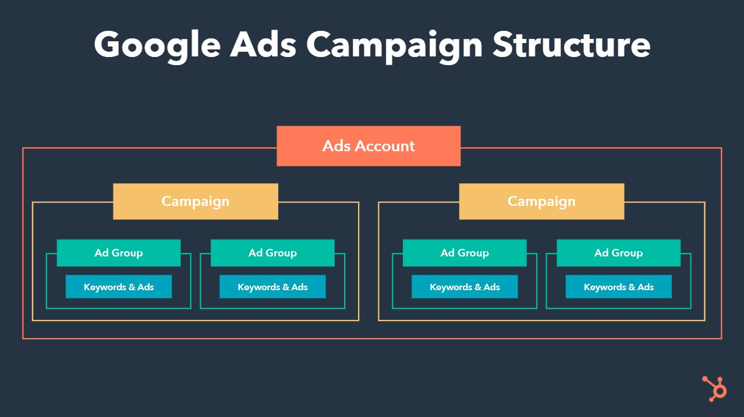.

**1. User Interface (UI):**

- The campaign management starts with a user-friendly interface where advertisers can interact with the system. This can be a web-based application or a mobile app.

**2. Authentication and Authorization:**

- Users need to authenticate themselves to access the system. Implement secure authentication methods, such as OAuth, to ensure the security of user accounts.

**3. Campaign Setup:**

- This is where advertisers define the campaign parameters, including budget, targeting, ad groups, and bidding strategies.

**4. API Integration:**

- Integrate with the Google Ads API to interact with the Google Ads platform programmatically. The API handles various tasks like creating and managing campaigns, ad groups, ads, keywords, and reporting.

**5. Campaign Management Engine:**

- This is the core of the system. It processes campaign setup and management requests, validates inputs, and communicates with the Google Ads API for actual campaign actions.

**6. Database:**

- Store essential data like campaign settings, user profiles, and performance metrics. This data is used for reporting, analysis, and optimization.

**7. Reporting and Analytics:**

- Generate reports based on campaign performance, including click-through rates, conversion rates, and ROI. Use analytics tools to gain insights and make data-driven decisions.

**8. Budget Management:**

- Monitor and manage campaign budgets. Ensure that spending stays within the allocated budget and implement rules for pausing or adjusting campaigns when necessary.

**9. **Keyword Research and Optimization**:**

- Integrate keyword research tools to identify relevant keywords and optimize your keyword strategy for better ad targeting.

**10. Ad Creatives and Landing Pages:**

- Manage ad creatives and landing pages, tracking their performance and making adjustments as needed.

**11. Bidding Strategy:**

- Implement algorithms or rules to adjust bidding strategies automatically, optimizing for clicks, conversions, or other KPIs.

**12. Error Handling and Logging:**

- Implement robust error handling to catch and handle exceptions. Maintain logs to track system activities and errors for debugging and audit purposes.

**13. Security Measures:**

- Ensure the security of user data, API tokens, and system components. Implement encryption, access controls, and regular security audits.

**14. Scalability and Load Balancing:**

- Design the architecture to scale horizontally and distribute the load to handle a large number of campaigns and users efficiently.

**15. Third-Party Integrations:**

- Integrate with third-party tools or services for additional functionality, such as CRM systems, email marketing, or social media advertising platforms.

**16. Quality Assurance and Testing:**

- Regularly test the system for functionality, performance, and security. Implement automated testing to catch issues early in the development process.

**17. Deployment and Monitoring:**

- Deploy the system to a reliable hosting environment and monitor its performance. Set up alerts for critical issues.

**18. Compliance and Policy Adherence:**

- Ensure that the system complies with Google Ads policies and best practices to avoid policy violations that could lead to account suspension.

**19. User Support and Help Center:**

- Provide user support channels, such as chat, email, or a help center, to assist users with questions or issues related to campaign management.

**20. Continuous Improvement:**

- Implement processes for continuous improvement and optimization based on user feedback and evolving advertising trends.

Project Design Phase-**||**

**Third-Party API’s**

**--------------------------------------------------------------------------------------------**

|  |  |
| --- | --- |
| NAME | T.SURESH KUMAR |
| NM ID | EA32343CFBC1AD09D4E465F983490A2F |
| PROJECT | HOW TO CREATE A GOOGLE ADS COMPAIGN FOR YOUR BRAND |

**THIRD PARTY API’S:**

* Firstly, you'll need to ensure you have a Google Ads account. If you don't have one, sign up at [Google Ads](https://ads.google.com), and set up your payment and billing details.
* Next, gain access to the necessary APIs. Create a project in the Google API Console and enable the Google Ads API to get started.
* Obtain API credentials, including a client ID, client secret, developer token, and refresh token, through the Google API Console.
* Choose a programming language to interact with the API. Common options include Python, Java, PHP, and Node.js.
* Set up your development environment by installing the required libraries or SDKs for your chosen programming language. Configure your project with the API credentials and authorization process.
* Start developing your application. Use the API to create campaigns, ad groups, ads, and keywords for your brand. You can configure various campaign settings like targeting, budget, and bidding strategy programmatically.
* Once your campaigns are live, you can use the API to monitor and optimize them. This may involve adjusting bidding strategies based on performance data or updating ad creatives.
* If you want to automate tasks, consider using the Google Ads Scripts API. This allows you to create JavaScript scripts to automate various aspects of your Google Ads account, such as reporting and bid management.
* Thoroughly test your application to ensure it's working correctly and not causing unintended changes to your campaigns.
* Make sure your use of the API complies with Google Ads policies and best practices to avoid policy violations.
* Set up monitoring and reporting systems to keep track of your campaign's performance and receive alerts for any issues or anomalies.
* Continuously analyze the results of your campaigns and make adjustments as necessary to improve their performance over time.
* Implement security measures to protect your API credentials and user data. Use secure coding practices and OAuth for authentication.
* Be aware of Google's API rate limits and usage policies to prevent access restrictions.
* Regularly refer to the Google Ads API documentation and seek support from Google Ads support or developer communities as needed.
* Project Development Phase
* **CODE-LAYOUT, READABILITY AND REUSABILITY**

|  |  |
| --- | --- |
| NAME | T.SURESH KUMAR |
| NM ID | EA32343CFBC1AD09D4E465F983490A2F |
| PROJECT | HOW TO CREATE A GOOGLE ADS COMPAIGN FOR YOUR BRAND |

* **Code Layout:**
* 1. Consistent Indentation: Use consistent and clear indentation (e.g., tabs or spaces) to structure your code. Follow industry-standard conventions for your chosen programming language.
* 2. Whitespace: Use whitespace judiciously to separate code blocks and make your code more readable. Avoid excessive or inconsistent use of whitespace.
* 3. Naming Conventions: Follow a consistent naming convention for variables, functions, classes, and other code elements. Use meaningful and descriptive names to make your code self-documenting.
* 4. Comments: Include comments to explain complex logic, algorithmic steps, or any non-obvious code. Make sure comments are concise, relevant, and up-to-date.
* 5. Code Organization: Organize your code into logical modules or files. Use directories and packages to structure your project. Maintain a clear directory structure.
* 6. Consistency: Adhere to a consistent coding style and formatting throughout your project. Use linters or code formatting tools to enforce code consistency.
* **Readability:**
* 1. Descriptive Function and Variable Names: Choose descriptive and meaningful names for functions and variables. A well-named function should indicate its purpose, and variable names should be self-explanatory.
* 2. Limit Line Length: Keep lines of code to a reasonable length (e.g., 80-120 characters) to improve readability. Break long lines into multiple lines when necessary.
* 3. Avoid Deep Nesting: Minimize deep nesting of loops and conditionals. Deeply nested code can become difficult to read and understand.
* 4. Modularization: Divide your code into small, manageable functions or methods with a single responsibility. This promotes code reuse and makes it easier to understand.
* 5. Use Design Patterns: Apply design patterns to solve common problems in a standardized and readable way. Well-known design patterns enhance code understandability.
* 6. Consistent Coding Style: Maintain a consistent coding style for your team or project. Agree on conventions for formatting, naming, and documentation.
* **Reusability:**
* 1. Functions and Libraries: Create functions and libraries that encapsulate common functionality. This allows you to reuse code across different parts of the system.
* 2. Parameterization: Design functions and modules with parameters that make them adaptable to various use cases. Avoid hardcoding values that could change.
* 3. Encapsulation: Encapsulate code in classes and objects, promoting code reuse through inheritance and composition.
* 4. Library and Module Management: Utilize external libraries and modules for common tasks whenever possible. Libraries like jQuery, Axios, or NumPy can save development time and improve reusability.
* 5. Version Control and Packaging: Use version control systems (e.g., Git) to manage your codebase. Package your code into reusable components, libraries, or microservices when applicable.
* 6. API Design: If your system exposes APIs or services, design them with reusability in mind. Follow RESTful principles or other best practices for API design.
* 7. Documentation: Document your code, APIs, and libraries comprehensively. Good documentation facilitates code reuse by explaining how to use your code effectively.

Project Development Phase-**||**

**Debugging & Traceability**

|  |  |
| --- | --- |
| NAME | T.SURESH KUMAR |
| NM ID | EA32343CFBC1AD09D4E465F983490A2F |
| PROJECT | HOW TO CREATE A GOOGLE ADS COMPAIGN FOR YOUR BRAND |

Debugging:

1. Logging: Implement comprehensive logging throughout your application. Use structured logs that capture relevant information about each operation, including timestamps, error details, and the user responsible. Logging can be useful for auditing and debugging.

2. Debugging Tools: Utilize integrated development environments (IDEs) and debugging tools provided by your chosen programming language. Tools like breakpoints, watches, and stack traces are valuable for isolating and fixing issues.

3. Exception Handling: Properly handle exceptions, including capturing exceptions in a structured way and providing clear error messages. Handle exceptions gracefully to prevent crashes and data corruption.

4. Unit Testing: Write unit tests to validate the functionality of individual components. This helps catch errors early in the development process and provides a safety net for future changes.

5. Integration Testing: Conduct integration tests to verify that different parts of your system work together as expected. This helps identify issues that may arise when components interact.

6. Version Control: Use version control systems (e.g., Git) to track code changes. Version control enables you to pinpoint when and why a change was made and helps with identifying the source of issues.

7. Code Review: Implement a code review process to have team members review each other's code. Code reviews can help catch logic errors, security vulnerabilities, and best practices violations.

Traceability:

1. Unique Identifiers: Assign unique identifiers to campaigns, ad groups, ads, keywords, and other elements in your system. This helps trace actions and changes back to specific entities.

2. Audit Trails: Maintain an audit trail of significant events, including who initiated the event, when it occurred, and the nature of the action. This can be useful for tracking changes and identifying accountability.

3. Data Flow Diagrams: Create data flow diagrams that illustrate how data moves through your system. This can help visualize the path of data and actions, making it easier to identify issues and dependencies.

4. Change Management: Implement a change management process to track and document changes to your system. This includes change requests, approvals, and the deployment of new versions.

5. User Activity Logs: Record user activities, such as logins, campaign creation, ad modifications, and settings changes. This traceability can help in identifying issues, auditing user actions, and ensuring accountability.

6. Request Tracing: Implement request tracing mechanisms that track the journey of a user's request through the system. This can help pinpoint bottlenecks and issues in request processing.

7. Custom Reporting: Develop custom reporting tools that allow you to retrieve historical data and track the performance of campaigns over time.

8. Integration with Monitoring Tools: Integrate your application with monitoring and observability tools (e.g., Prometheus, Grafana) to track system performance and receive alerts when anomalies occur.

Project Development Phase

**Exception Handling**

|  |  |
| --- | --- |
| NAME | T.SURESH KUMAR |
| NM ID | EA32343CFBC1AD09D4E465F983490A2F |
| PROJECT | HOW TO CREATE A GOOGLE ADS COMPAIGN FOR YOUR BRAND |

Exception handling is an essential aspect of software development to ensure that your system can gracefully handle unexpected errors and issues. In the context of creating a Google Ads campaign for your brand, here are some common exception handling considerations:

1. Google Ads API Exceptions:

- When interacting with the Google Ads API, handle exceptions that might occur during API calls. These could include authentication errors, rate limit exceeded errors, and other API-specific issues.

2. User Input Validation:

- Validate user input to prevent data errors and security vulnerabilities. Handle exceptions for invalid input, missing fields, or incorrect data formats.

3. Authentication and Authorization Errors:

- Implement error handling for authentication and authorization issues. When users or external systems access the campaign management platform, ensure that unauthorized access attempts are properly handled.

4. Network and Connectivity Issues:

- Handle exceptions related to network and connectivity problems. This includes handling timeouts, lost connections, and ensuring that your system retries requests when appropriate.

5. Data Storage and Database Exceptions:

- Address exceptions related to data storage and database operations. This includes handling database connection issues, query errors, and ensuring data integrity.

6. Security Exceptions:

- Implement security measures to handle security-related exceptions, such as potential breaches, injection attacks, and other security vulnerabilities.

7. Logging and Auditing:

- Properly log exceptions and errors for auditing and debugging purposes. Use a structured logging approach to capture relevant information about exceptions.

8. Notification of Critical Events:

- Set up notifications for critical events, such as system outages or policy violations, to alert administrators and users promptly.

9. Custom Exceptions:

- Create custom exception classes to handle specific application-related errors effectively. These exceptions should provide meaningful error messages and context.

10. Exception Recovery and Graceful Degradation:

- Plan for exception recovery and graceful degradation strategies. In the event of an exception, your system should try to recover gracefully, continue essential functions, and provide a degraded but functional experience.

11. Documentation and Error Messages:

- Ensure that error messages and documentation are clear and helpful for both developers and end-users to understand the issue and take appropriate actions.

12. Testing and Validation:

- Test your exception handling thoroughly through unit tests, integration tests, and error scenario simulations to verify that the system behaves as expected under various exceptional conditions.

13. Scalability and Redundancy:

- Consider how exception handling fits into your system's scalability and redundancy plans. Ensure that handling exceptions doesn't introduce bottlenecks or single points of failure.

By addressing these exception handling considerations, you can build a robust campaign management system for creating Google Ads campaigns for your brand. Exception handling not only improves system reliability but also helps maintain a positive user experience and security posture.

Project Development Phase

**No. Of Functional Features Included In the Solution**

|  |  |
| --- | --- |
| NAME | T.SURESH KUMAR |
| NM ID | EA32343CFBC1AD09D4E465F983490A2F |
| PROJECT | HOW TO CREATE A GOOGLE ADS COMPAIGN FOR YOUR BRAND |

|  |  |
| --- | --- |
| **Functional Feature** | **Description** |
| User Authentication and Authorization | - User registration and login. - Role-based access control to manage user permissions. |
| Campaign Management | - Create, edit, and delete campaigns. - Specify campaign name, objectives, and budget. - Choose bidding strategies. - Manage multiple campaigns. |
| Ad Group Management | - Create, edit, and delete ad groups. - Define ad group names and targeting options. - Organize ad groups within campaigns. |
| Ad Copy Creation and Management | - Create ad copies with headlines, descriptions, and display URLs. - Enable A/B testing for ad variations. - Schedule ad copy changes. |
| Keyword Management | - Research and select relevant keywords. - Organize keywords into ad groups. - Define negative keywords to enhance ad relevance. |
| Landing Page Management | - Specify landing pages for ads. - Ensure landing page quality and relevance to ad content. |
| Bid Management | - Set keyword bids and bidding strategies. - Adjust bids based on performance data. |
| Audience Targeting | - Define audience targeting options, such as demographics and interests. - Implement remarketing strategies. |
| Ad Scheduling | - Schedule ad display times and dates. - Define ad rotation settings. |
| Conversion Tracking | - Set up conversion tracking to measure campaign success. - Define conversion actions and values. |
| Real-Time Notifications | - Send real-time alerts and notifications for campaign-related events (e.g., budget changes, policy violations). |
| Performance Reporting and Analytics | - Generate custom reports with key performance metrics (e.g., CTR, conversion rates, ROAS). - Provide data visualizations for campaign analysis. |
| Data Storage and Management | - Store campaign data, user profiles, and performance metrics securely. - Implement data encryption and regular backups. |
| Google Ads API Integration | - Communicate with the Google Ads API for campaign creation, management, and optimization. - Manage authentication and access to Google Ads. |
| Compliance Management | - Ensure adherence to Google Ads policies and guidelines to avoid policy violations. - Conduct regular reviews and updates for policy compliance. |
| Monitoring and Logging | - Implement real-time system health and performance monitoring. - Log system activities for debugging and auditing. |
| Security Measures | - Implement strong data encryption protocols to protect sensitive information. - Enforce role-based access control to ensure data privacy. |
| Containerization and Orchestration | - Use containerization (e.g., Docker) and orchestration (e.g., Kubernetes) for resource management. |
| Continuous Optimization | - Continuously monitor campaign performance. - Regularly analyze data insights and make adjustments to optimize campaigns. |

Project Development Phase

**Utilization of Algorithm, dynamic programming ,optional memory utilization**

|  |  |
| --- | --- |
| NAME | T.SURESH KUMAR |
| NM ID | EA32343CFBC1AD09D4E465F983490A2F |
| PROJECT | HOW TO CREATE A GOOGLE ADS COMPAIGN FOR YOUR BRAND |

Creating a Google Ads campaign for your brand involves setting up a campaign, creating ad groups, and designing ads. Dynamic programming and memory optimization are not typically used in the creation of Google Ads campaigns, as they are more relevant to computer science and algorithmic problems. However, I can provide you with a basic outline of how to create a Google Ads campaign for your brand.

1. Sign in to Google Ads:

- Visit the Google Ads website (ads.google.com).

- Sign in with your Google account or create one if you don't have it.

2. Create a Campaign:

- Click on "Campaigns" in the left menu.

- Click the "+ New Campaign" button.

- Choose the campaign type that aligns with your goals, such as Search, Display, Video, or Shopping.

3. Select Campaign Settings:

- Give your campaign a name.

- Choose your target locations.

- Set a daily budget.

- Choose bidding strategy (e.g., maximize clicks, target CPA, or manual CPC).

- Set the start and end date for your campaign.

4. Create Ad Groups:

- Within your campaign, create ad groups that represent specific themes or products.

- Name your ad groups accordingly.

- Define keywords that are relevant to each ad group.

5. Design Ads:

- Create compelling text, image, or video ads for each ad group.

- Follow Google Ads guidelines for ad formats and dimensions.

- Include relevant keywords in your ad copy.

6. Set Ad Targeting:

- Specify the demographics, interests, and other targeting options for your ads.

- Use audience targeting to reach specific user groups.

7. Choose Keywords:

- Add relevant keywords to your ad groups.

- Use the Keyword Planner tool to find keyword suggestions and estimate search volume.

8. Set up Tracking:

- Implement conversion tracking to measure the success of your campaign.

- Use Google Analytics or Google Tag Manager to track website conversions.

9. Review and Launch:

- Review your campaign settings, ad groups, ads, and keywords.

- Once everything looks good, click the "Launch" button to start your campaign.

10. Monitor and Optimize:

- Regularly monitor your campaign's performance.

- Adjust your budget, bids, and targeting as needed.

- Test different ad variations to see which ones perform best.

- Use Google Ads' reporting tools to gather insights and make data-driven decisions.

Dynamic programming and memory optimization are generally not applicable to this process. They are computer science techniques used to solve complex problems, optimize algorithms, and reduce computational complexity. If you have a specific technical problem related to dynamic programming or memory optimization, please provide more details, and I can assist you further.

Performance and Final Submission Phase

**Model Performance Metrics**

|  |  |
| --- | --- |
| NAME | T.SURESH KUMAR |
| NM ID | EA32343CFBC1AD09D4E465F983490A2F |
| PROJECT | HOW TO CREATE A GOOGLE ADS COMPAIGN FOR YOUR BRAND |

|  |  |
| --- | --- |
| **PARAMETER** | **SCREENSHOT** |
| Output |  |